**Introduction**

Pain is an extremely prevalent symptom. Chronic pain alone is estimated to affect 30% of the adult population of the USA, upwards of 100 million adults.[1](https://www.ncbi.nlm.nih.gov/pmc/articles/PMC3841375/#AET124C1) In addition to being highly prevalent, pain is exceedingly costly to the individual with chronic pain, his or her significant others, and society. The expenses for chronic pain involve not only traditional healthcare but also indirect costs such as lost productivity at work, lost tax revenue, legal services, and disability compensation. Estimates of the total annual costs of chronic pain (including treatment, lost work days, disability payments, and legal fees) in the USA range from US$550 to 625 billion per year.

Despite the soaring cost of treating people with chronic pain, relief for many remains elusive and complete elimination of pain is rare. Although there have been substantial advances in the knowledge of the neurophysiology of pain, along with the development of potent analgesic medications and other innovative medical and surgical interventions, on average the amount of pain reduction by available procedures is 30–40% and this occurs in fewer than one-half of treated patients. Thus, the majority of people with painful conditions continue to experience significant pain that impairs their quality of life, causing significant physical disability and emotional distress.

**Comprehensive assessment of the person with chronic pain**

1. What is the extent of the patient's disease or injury (physical impairment)?
2. What is the magnitude of the illness? That is, to what extent is the patient suffering, disabled, and unable to enjoy usual activities?
3. Does the individual's behaviour seem appropriate to the disease or injury, or is there any evidence of symptom amplification for any of a variety of psychological or social reasons (e.g. benefits such as positive attention, mood-altering medications, financial compensation)?

To answer these questions, information should be gathered from the patient by history and physical examination, in combination with a clinical interview, and through standardized assessment instruments. Healthcare providers need to seek any cause(s) of pain through physical examination and diagnostic tests while concomitantly assessing the patient’s mood, fears, expectancies, coping efforts, resources, responses of significant others, and the impact of pain on the patients’ lives. In short, the healthcare provider must evaluate the ‘whole person’ and not just the pain.

**Solution**

1. **Interview** - In addition to this standard medical evaluation approach, an appropriate patient assessment requires an evaluation of the myriad psychosocial and behavioural factors that influence the subjective report of the characteristics of the pain, which can be done through interviewing.
2. **Standardize Pain Assessment** - Information obtained from the interview can be invaluable as a means to determine which, if any, further assessments should be administered that are of particular relevance to the specific patient. In addition to the interview, self-report measures have become the gold standard for the assessment of patients reporting pain, including relevant contributing factors.
3. **Integrative Medicine Group Visits** (IMGV) incorporates MBSR and Integrative medicine with a conventional group medical visit to improve the health and well-being of patients with multiple chronic conditions.

**Integrative Medicine Group Visits**

The Integrative Medicine Group Visits (IMGVs) program is an 8-week clinical program that combines Mindfulness-Based Stress Reduction (MBSR) with patient education and integrative medicine therapies. IMGVs take place in the Family Medicine clinic at Boston Medical Center.  Each week, a group of 8-10 patients meet for 2.5 hours in a group co-led by a family medicine physician and MBSR instructor. Patients practice MBSR with the instructor, discuss a health topic relevant to the group with the physician, and then participate in an integrative medicine activity like yoga, cooking, massage, or acupuncture. IMGVs incorporate time for individual patient care following the group visit.

Mindfulness is:

1. Mindfulness is paying attention.
2. Mindfulness is being in the present moment without judgment.
3. Mindfulness helps us to develop greater awareness and acceptance.

Mindfulness offers:

1. A way of reducing stress.
2. An ability to be less reactive to a wide range of situations.
3. An ability to be present, to be fully awake to life.
4. A method for increasing concentration and focus.

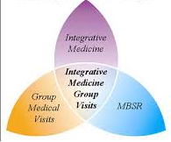

**Qualitative Theme**

**Solution**

An iOS based application for Integrative Medicine and Health Disparities which access chronic pain and chronic condition of patient, by asking patient to take small survey which results the real condition of the person. It is similar to interview the patient but with the help of application.

The answers to the application is shared by the doctor automatically, based on which doctor can evaluate the patient condition and provide him with mindful approach to reduce the pain.

**Application Features**

1. Patient portal with secure login functionality
2. View patient’s profile, which display contact information, current health conditions along with height and weight.
3. Patient can edit his profile for once.
4. Small survey has to be given by patient whenever he/she feel the urge to have medicine.
5. Based on the answers, patient is provided with number of solution from watching mindful video, performing some Yoga or acupressure.
6. Answer to the survey is sent to the doctor in the report format, which he can evaluate.
7. Portal for updating the medicine taken in a day based on the prescription given to the patient.
8. Facility to place a request for medicine
9. Chat portal which has multiple group based on the category of pain.
10. Patient will be added to the group by doctor. There are two groups
    1. **Public Group**: Groups which are available to all the patients
    2. **Private Group**: Group which has limited users, which are added by the doctor
11. Patient can send text messages and send images to the group and discuss about his conditions, where people having same pain can relate understand and provide patient with better solution.
12. Patient can play YouTube video or listen to music provided by the doctor and provide the feedback of the video.

**Screenshots**

1. **Menu Bar**

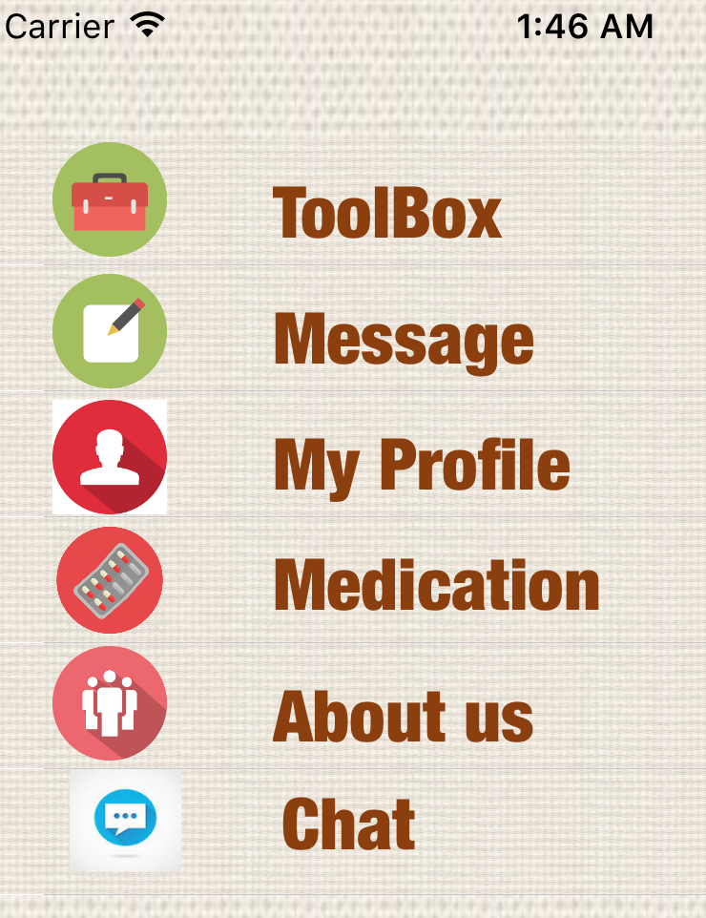

1. **Survey Questions**

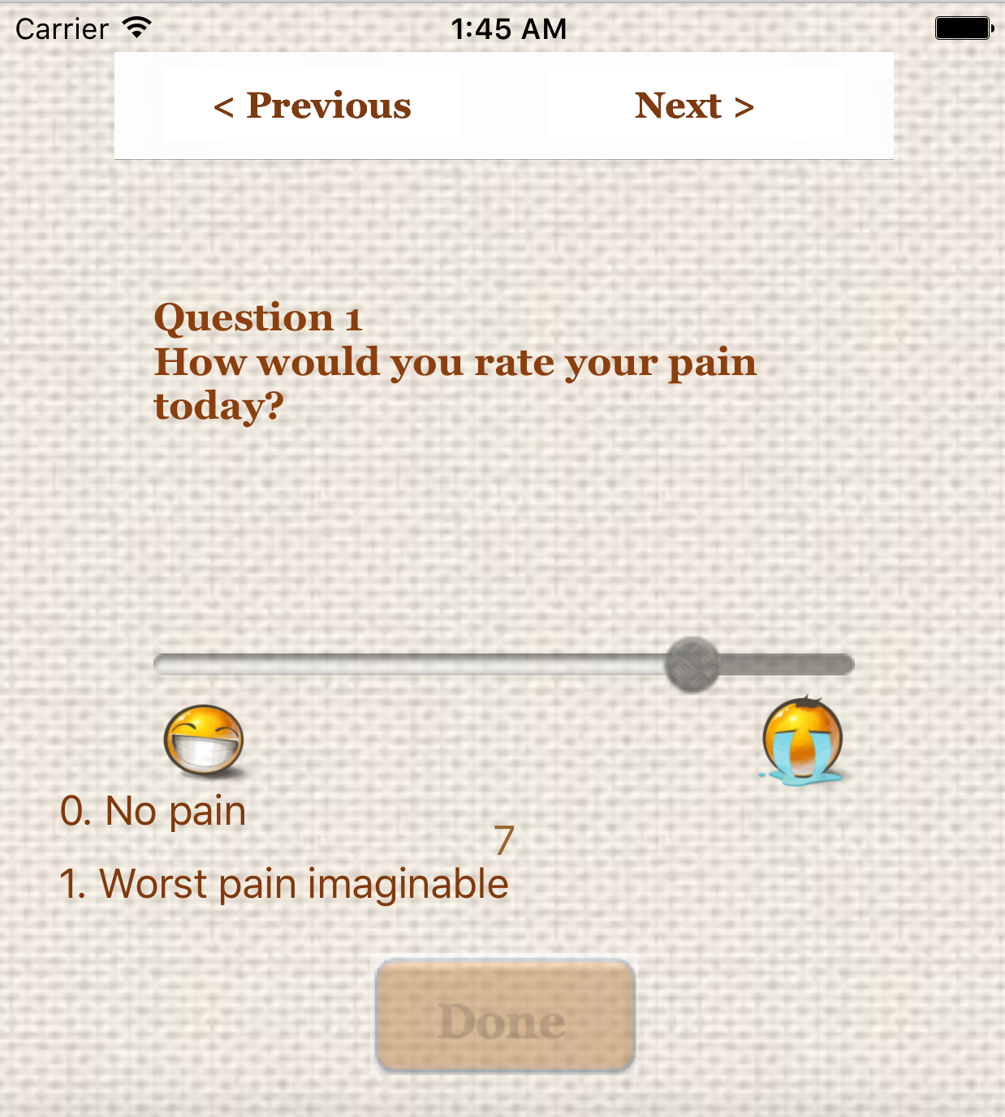

1. **YouTube Video**



1. **Edit Profile**

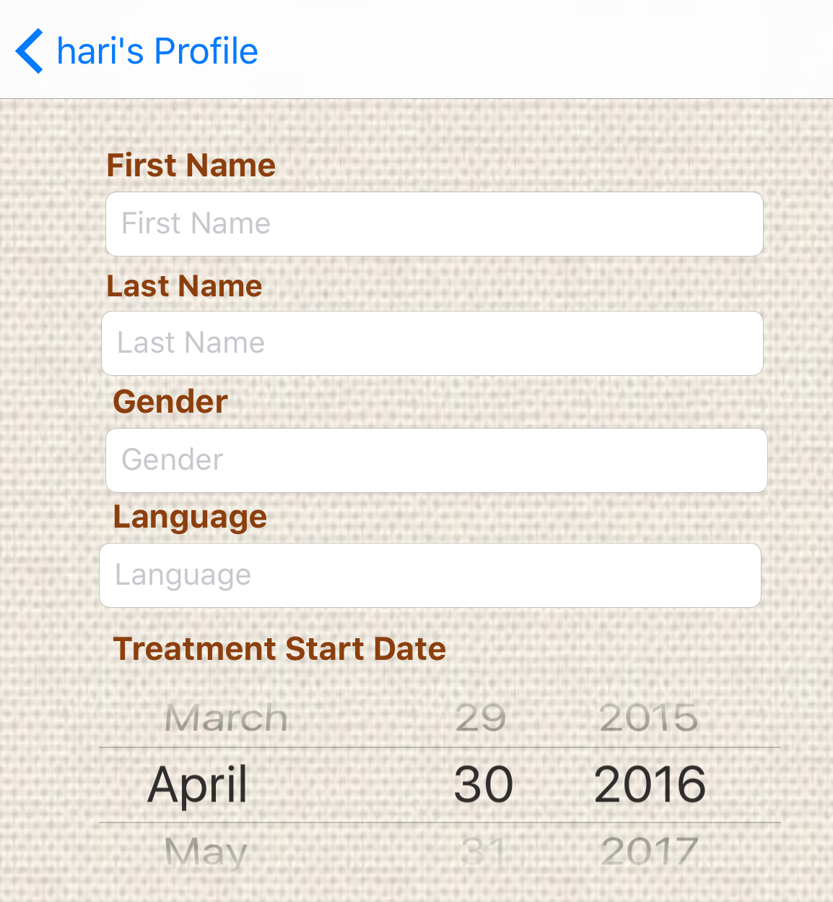

1. **Group of the users**

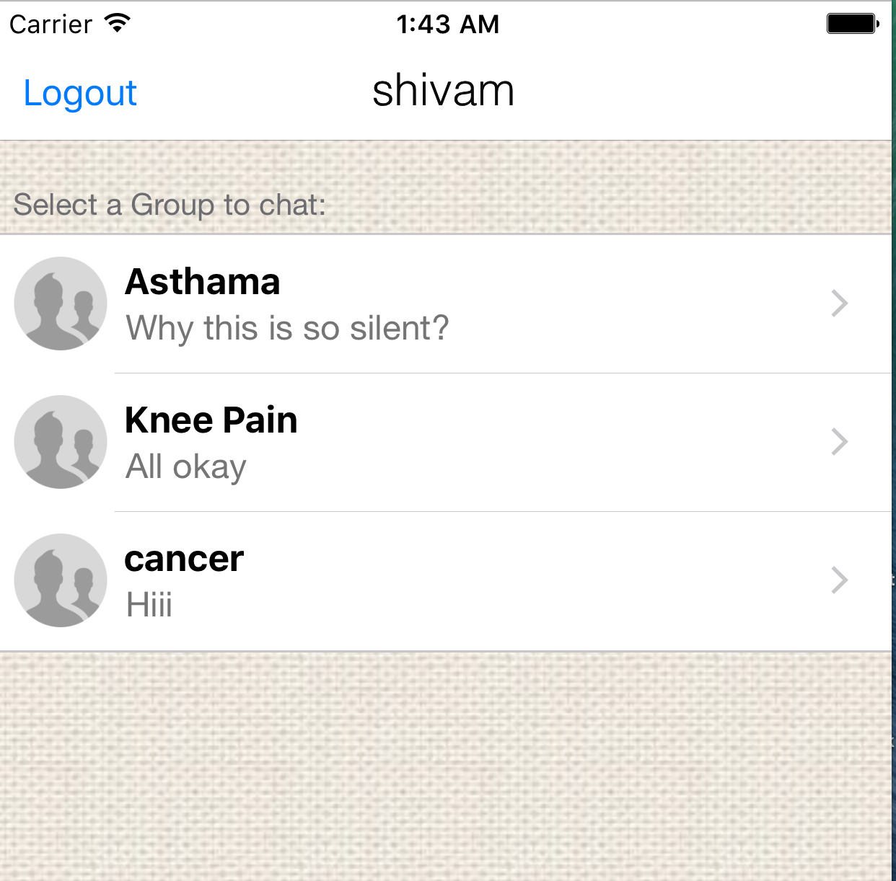

1. **Chat Panel**

